Geo-Speak

Supervisor: | Zaman.
Group: | Geo Speak
Serial No. | Enrollment No. | Student Name.
1. | 1395226 | Muhammad Shawaiz
2. | 1406443 | Sameer Kandara
3. | 1397780 | Hawa
4. | 1397777 | Saood

Acknowledgement

The first, we would like to express my special thanks of gratitude to my teacher SIR ZAMAN who helped a lot in finalizing this project within the limited time frame, valuable counseling and assistance for the accomplishment of this project.
Secondly, we would also like to thanks the e-project team at Aptech Head Office, who gave as the opportunity to do this interesting and wonderful project about Geo-Speak
Thirdly, we also thank the e-project team for giving this task to us. Following are the benefits of this Project:
The project involves developing an intelligent translation application utilizing (Gen AI), Large LLMs, and technologies from OpenAI or other relevant model. The application will be designed to process user input provided in the form of text input. Some of the functional requirements are as follows:

Text Input
- Description: The application must allow users to input text in a source language and select a target language from a drop-down menu.
- Implementation Details:
  - Input box for the source text.
  - Dropdown menu for selecting the target language.
  - Multi-language support.
- Acceptance Criteria:
  - The user can input text and select any target language before submitting for translation.

Text Processing
- Description: The system must process the input text using an Embedding API to generate a high-dimensional semantic vector.
- Implementation Details:
  - Integration with a pre-trained embedding model (such as OpenAI embeddings).
  - Conversion of the input text into a high-dimensional semantic vector.
- Acceptance Criteria:
  - Text is correctly transformed into a vector that can be used for further processing.

Document Retrieval
- Description: The system must query a Vector Database to retrieve relevant documents based on the generated embedding vector.
- Implementation Details:
  - Use of a vector database like Pinecone, Weaviate, or FAISS.
  - Search for relevant documents based on semantic similarity of vectors.
- Acceptance Criteria:
  - Retrieval of documents with similar embeddings to the input text vector.

Context-aware Prompt Creation
- Description: The system must generate a context-aware prompt that guides the translation model in translating the input text more accurately.
- Implementation Details:
  - Dynamic prompt generation based on retrieved documents and semantic understanding of input text.
  - Context-awareness based on surrounding text or document.
- Acceptance Criteria:
  - The generated prompt enhances translation accuracy by incorporating the input text’s context.

Translation Generation
- Description: The system must use a Language Model to generate a translation of the source text based on the context-aware prompt.
- Implementation Details:
  - Integration with a Large Language Model (LLM) like OpenAI’s GPT-4.
  - Ensure that the translation is contextually accurate and adheres to nuances of both source and target languages.
- Acceptance Criteria:
  - Translated output is contextually accurate and aligns with the intended meaning of the input text.

Result Display
- Description: The translated text must be presented to the user in a clear and user-friendly format.
- Implementation Details:
  - Display translated output in a designated area within the user interface.
  - Clear demarcation of source and translated text.
  - Option to copy or download translated text.
- Acceptance Criteria:
  - Users can easily view and interact with the translated output.

Error Handling
- Description: The system must handle errors in text processing, document retrieval, and translation generation gracefully.
- Implementation Details:
  - Implement error handling mechanisms for common failures such as API request timeouts or failed document retrieval.
  - Provide user-friendly error messages and suggest solutions where appropriate.
- Acceptance Criteria:
  - The system can identify and handle errors, presenting informative messages to the user.

User Interface
- Description: The application must provide an intuitive and responsive user interface for input, language selection, and viewing translation results.
- Implementation Details:
  - Design of a clean and user-friendly interface using modern UI frameworks (e.g., React, Vue.js).
  - Responsive layout for different device types (desktop, tablet, mobile).
- Acceptance Criteria:
  - Users can navigate and operate the interface smoothly across multiple devices and platforms.

Task Sheet
Project Ref.No:  Ep/Advertisement  Portal Management  System /01 |  | ProjectTitle | Date Of preparation Of Activity Plan
No. | Task | G  E  O  -  S  P  E  A  K | Actual  Start Date | Actual Days | Team-Mate  Name | Status
01. | Home page | G  E  O  -  S  P  E  A  K | 18  -  S  E  P  -  2  0  2  4 | 5  -  D  A  Y  S  - | All
02 | Red me file &  User Guide | G  E  O  -  S  P  E  A  K | 18  -  S  E  P  -  2  0  2  4 | 5  -  D  A  Y  S  - | Saood
03 | Api’s integration & Back-End Code | G  E  O  -  S  P  E  A  K | 18  -  S  E  P  -  2  0  2  4 | 5  -  D  A  Y  S  - | Sameer kandara
04 | Database integration & Back-End Code | G  E  O  -  S  P  E  A  K | 18  -  S  E  P  -  2  0  2  4 | 5  -  D  A  Y  S  - | Hawa
05. | Documentation , User-Guide, Readme file | G  E  O  -  S  P  E  A  K | 18  -  S  E  P  -  2  0  2  4 | 5  -  D  A  Y  S  - | Muhammad Shawaiz

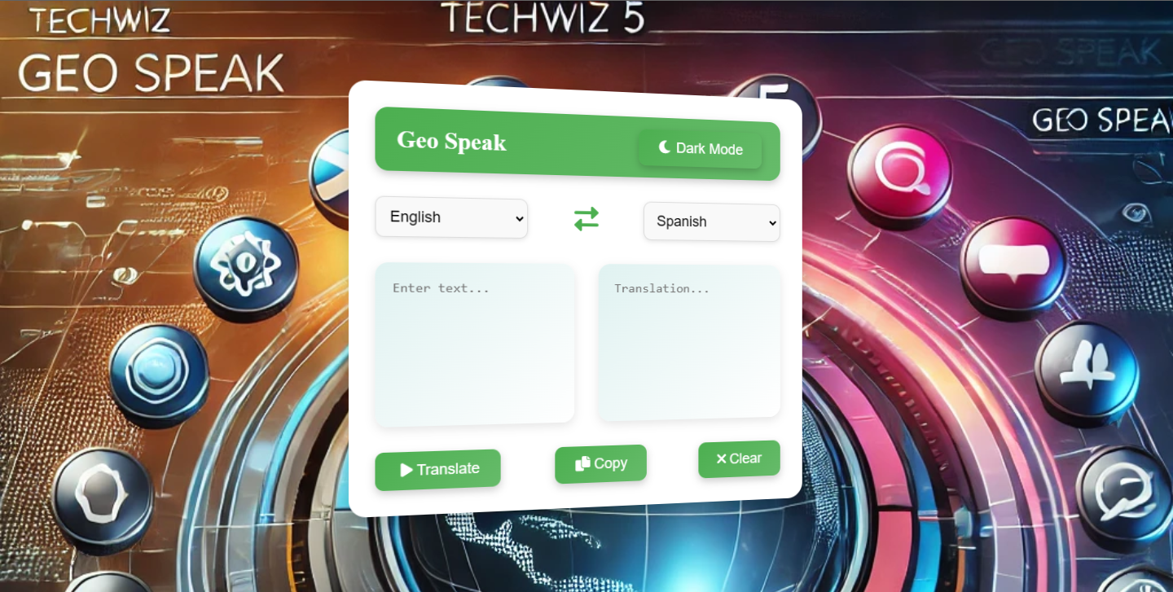
Description:
The image shows the interface of a language translation application called Geo Speak. The UI has an option to toggle Dark Mode and allows users to translate text between different languages. The interface includes drop-down menus for selecting the input and output languages, a text area to enter the text, and buttons to Translate, Copy, or Clear the translated output. The background features a futuristic design with various icons and a digital globe, reinforcing the global nature of the translation service.

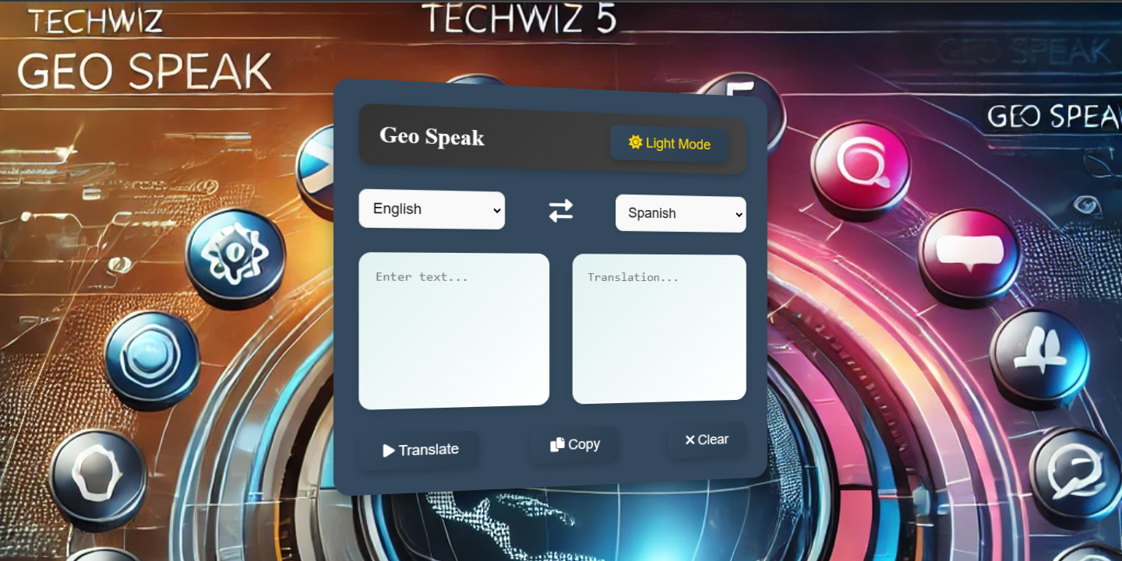
Description: The image shows the interface of a language translation application called Geo Speak. The UI has an option to toggle Light Mode and allows users to translate text between different languages. The interface includes drop-down menus for selecting the input and output languages, a text area to enter the text, and buttons to Translate, Copy, or Clear the translated output. The background features a futuristic design with various icons and a digital globe, reinforcing the global nature of the translation service.

